Welcome back Edmunds Elementary
School Hours: 7:30- 2:40 Phone number: 515-242-8406
Safety | Attendance | Learning Expectations
- Everyone on school property MUST properly wear a face covering, this is mandatory  - Face shields alone, bandana’s and gators are not approved  - Mask breaks will be provided  - Social distance whenever possible  - Hand sanitizing and washing will be done frequently  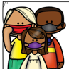  - Water fountains are closed, bring a water bottle | - Look for the large A or B in the main window to indicate which cohort should be at school  - Attendance will be taken daily for all students on all days both Hybrid and Virtual  - Stay home when you are sick  - Contact Edmunds  if your child is unable to attend school | - Student will receive core instruction from an Edmunds teacher on both Hybrid and Virtual days  - Participate in independent work online through Canvas  - Complete and submit assigned work tasks  - Ask for help  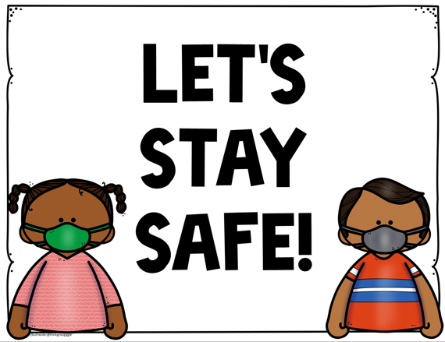
Arrival & Dismissal
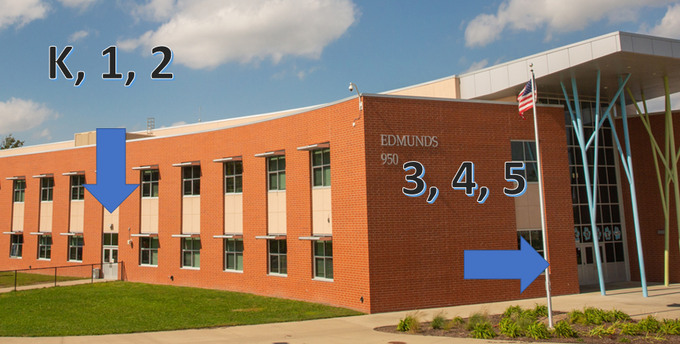
- Parents/caregivers must remain in their vehicles, teachers are stationed throughout the building and will help students get to their correct location.
- Bus students will enter using the NE door (same as last year).
We are here to help!
Edmunds Information
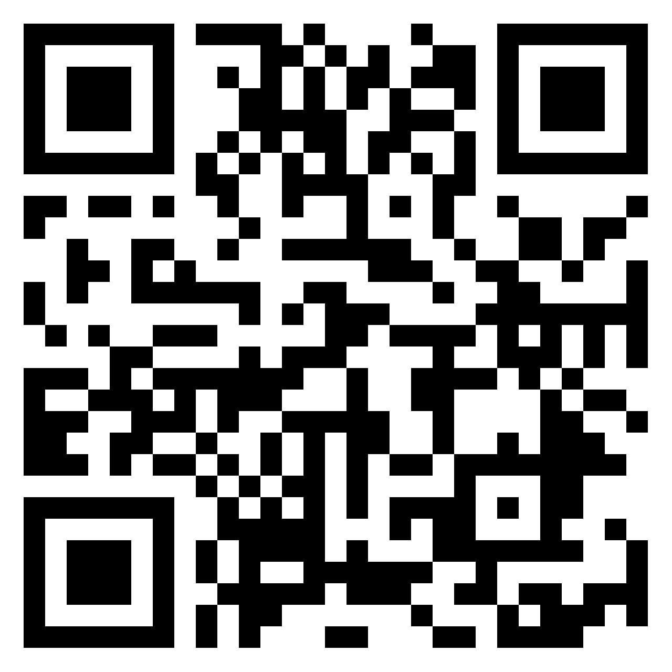  - Padlet  -newsletters and general information  -visit the link below  -scan the QR code  https://padlet.com/melissaosby/1ndtveyr9rn2 | - Edmunds School Website  https://edmunds.dmschools.org/  - Follow us on Facebook
Technology | FREE Meals
- Encourage students to keep computer in a safe space  - If a computer is broken or damaged call school right away so it can be fixed  - DMPS Technology help number  515-242-8221  - If you need internet access, please call Edmunds 515-242-8406 | - Each day students are at school they will bring home a breakfast and a lunch for their at home day  - Virtual students may pick up meals:  -October 19-23, at Callanan Middle School from 11-1pm  -October 26- November 10 from 11- 1pm at North/Roosevelt High School  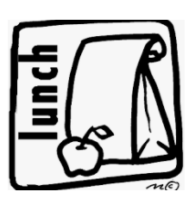  - Starting November 10 meals will need to be ordered and picked up at a site to be determined. More information to come
Need More Resources
Visit: www.dmschools.org/familyresources
- Resources available for:  - Childcare  - Housing Assistance  - Food Assistance  - Medical Coverage Assistance  - Employment  - Financial Assistance  - Legal Assistance  - Complete the Student Services Contact Form for assistance with additional family needs or supports | 