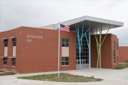
  - Edmunds Elementary Wildcat Newsletter:
  - On the Prowl
September

Smarter…Better…Edmunds Power! |  | Important Dates

Attendance

Research has consistently shown that students who attend school regularly and on time usually experience more academic success.
There are times when children should not be at school because of illness, injury, or other reasons. It is the parent’s responsibility to contact the school by 8:00 am if a child will not be in school. If your child needs to be excused from school for a doctor or dentists appointment, please let the office know in the morning. Please sign your child out when you leave and back in when you return.
Edmunds school hours are 8:00 am to 3:10 pm. Every Wednesday early dismissal at 1:40 pm. Doors open at 7:40. Students will enter the building through the Northeast door. If they are late, they will need to come in through the main doors and check in at the office for a pass to class. Breakfast is served daily to all students beginning at 7:50.

Welcome Back!
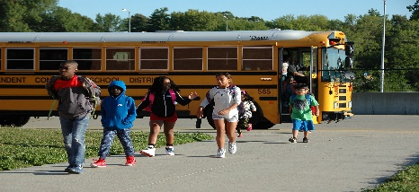
1st Day of School!

The first day of school can be exciting and scary at the same time. Edmunds kids started the year off with a great week, including the opportunity to practice school expectations, encapsulated by the school code of behavior: Respectful, Responsible and Caring. The first few days of school included students rotating through different responsibilities of daily expectations at school; moving from classroom to classroom, bus loading procedures, raising your hand, lining up, playground expectations, etc. All classes take place in these "rotations," helping prepare students for the exciting new 2017-18 school year!
9.4.2017
No School – Labor Day

9.21.2017
Parent Activity Fun Night! 5-6:30pm

9.29.2017
Popcorn Friday $.50

10.4.2017 Early Dismissal 1:40 Parent Teacher Conferences 2-8pm

10.5.2017 Parent Teacher Conferences 4-8pm
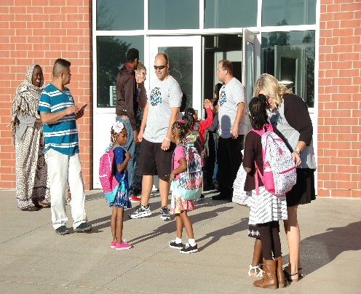

Dismissal Procedure.

Bus riders will exit with teacher to the North side of the building when the bus arrives. Read and review the bus conduct procedures. Expectations will be followed or privilege will be suspended.
Day Care Pick Up: Wilkie House and Oakridge vans will be located on the West side of the building. Students will be walked out the back door and placed on the van.
Walkers going East will exit out the East doors with a teacher. Student will be walked to the corner and cross the street with a staff member. Walkers traveling South will exit the East doors. Students will be walked to the crosswalk and cross using the crossing guard.
Parent Pick Up and Drop Off:
- Students need to use the crosswalk when crossing into the parking lot.
- Pick up and drop off located on the East side of the building ONLY!
- Enter West bound from 17th street and follow North to School Street. Turn right on 15th street and first right to begin forming a pick-up line by turning into the pick-up lane and pulling all the way to the far South end.
- There will be NO PARKING: No Stopping, or standing North on 15th Street
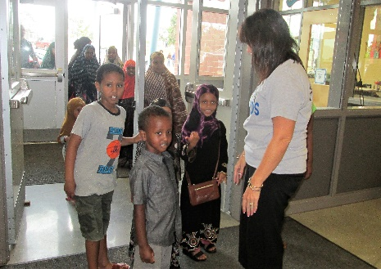
- No left turn from 15th Street into the Edmunds parking lot.
- Stay in your cars and students will be brought to you while in the pick-up lane. When you have your child pull into the drive thru lane and exit right turn only.
- Students will stand by signs. Lower Unit (K-2) and Upper Unit (3-5)
- Vary your arrival times 3:00 – 3:10. Students will always be supervised.
- Right Lane is for drop-off and pick up ONLY!
- Left Lane is for drive thru traffic ONLY!
- When you have picked up your child exit by moving into the left lane and proceeding out through the exit.

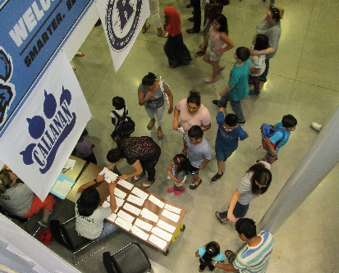
Open House
Edmunds held their Open House the 2017-18 School Year on Monday August 21st, with hundreds of students, parents and community friends attending. New and returning students at Edmunds Elementary were welcomed to meet their teachers and get a head start on an exciting new year. Even neighbors without kids at school, from The Oakridge and Sherman Hills neighborhoods, stopped by to see what all the excitement was about.
Edmunds Elementary students have start every morning with daily Yoga instruction. With a positive language of wellness and focus, the “Yoga 4 Classrooms” program was designed to help students achieving stress reduction and to support wellness and community for the students and teachers. Edmunds is the only Elementary school in the state that is participating in “Yoga 4 Classrooms®,” an innovative program designed to improve student’s physical, emotional and comprehension skills in school. Edmunds’ teachers have participated in a one day seminar to learn the basics of this exciting program, and several teachers went to advanced training as a follow up, and they are now helping to lead the yoga curriculum.
Students in all grades from Kindergarten through 5th grade start the day with a 20 minute yoga session, learning how to be “mindful” of their physical and emotional centers. There is also a daily afternoon session, and all of the teachers at Edmunds are participating with the students. Edmunds Principal Jaynette Rittman says that there has been “…a very positive response from both the teachers and students for the Yoga 4 Classrooms® philosophy. Our hope is that this creative program will help Edmunds’ students be more successful in their busy day and help them to develop the skills and knowledge that they need!”

Sing Along with Ms. Conner
Hello, my name is Carliann Northfield. I am very excited to be back at Edmunds. It has been wonderful to see everyone back from summer, and to get to know some new faces. We have already had a great start to the school year! Students are doing a fabulous job learning what the expectations are in music class. We are already starting to work on reviewing rhythm content and reaching forward to new content in grades two through five. In kindergarten and first grades we are working hard at practicing a steady beat and matching pitch. I am excited to see what students will accomplish, and how they grow in their learning as the year moves forward! We will be doing some pre-assessments to chart their growth this month. Keep up the great work!
In the World of Art with Mr. Borzo
We are excited about the new school year and we’re getting down to business right. Art for this new school year promises to be our best year ever! Many classes have already begun their first projects: Older classes are studying Leonardo Da Vinci and the painting “Mona Lisa.” Students are making their own parodies of the famous painting. Some younger classes are studying patterns and colors, as they learn about the routines and requirements in art. Classes will soon begin working on some Carnival themed art for our upcoming Family Fun Night at Edmunds! We are also looking ahead to many art competitions this fall, giving students a chance to put their art work and imagination to work! The art room has also received a substantial donation from many generous donors over this last summer, through the “DonorsChoose.org” organization. Art instructor David Borzo created a request for funds to provide students from 3nd through 5th grades with a personal drawing pad. Along with the request was a summary of the art program at Edmunds, and how we teach students to use mind and pencil to plan out their art work. These drawing pads will make that process more productive as the students use them throughout the school year. At the end of the year they will get to take the sketch pads home and show off all their fine work!
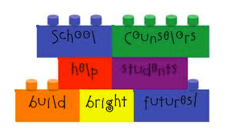
Counselor Corner with Mrs. Moore
I am very excited for my 3rd year as the counselor at Edmunds! I am looking forward to supporting all Edmunds students as they learn and grow. All students K-5 will receive a 30-minute counseling lesson each week. We will start the year off learning about the role of a counselor and about self-regulation. In addition to classroom counseling lessons, I will meet with some students individually or in small groups. Examples of things I may meet with your student about include: friendship, conflict resolution, social skills, attendance, and school success skills. If you have questions or need any support for your child, please feel free to call the school or email me at taylor.moore@dmschools.org. I am here to help!
Let the Games Begin in P.E. with Mr. Heard
Welcome back for another great year in Physical Education! My son is now almost one year old! We have a very busy month ahead of us in PE. At the beginning of September, we will be working on expectations during PE and recess, learning basic locomotor movements, and working on chasing/fleeing games such as tag or invasion. During the middle of the month, we will start our Fall Fitness Testing using the Fitnessgram testing method. Students will be performing the PACER test, push-ups, curl-ups, and flexibility tests. I will also be taking their height and weight to see how much they are growing. Please help your student remember the expectations for P.E. The P.E. Expectations are: Stay Safe, Listen to Instructions, Respect Others and the Equipment, Wear Proper Clothing and Shoes, Participate and Have Fun!

Title I Parent “Right to Know” Requirements

Parent Notification – “Right to Know”

- Parents of students in Title I schools are guaranteed annual notification of their “right to know” about teacher qualifications by their school district. That means parents may request and receive from that office information regarding the professional qualifications of the student’s classroom teachers, including:
- whether the teacher is state‐certified;
- whether a teacher is teaching under emergency or other provisional status; and
- the baccalaureate degree major of the teacher and any other graduate degree major or certification.
- whether the child is provided services by a paraprofessional and, if so, his/her
- qualifications.

- LEAs must notify parents at the beginning of each year that information on the professional qualifications of their child’s classroom teacher is available from the school district.
  - Notification may be included in district news letters or other communications to parents
  - Documentation of annual notification should be kept by LEA for monitoring purposes
  - Assurance that notification will occur should a child be taught for four or more weeks by a teacher who is not highly qualified

- Parents must receive timely notice that their child has been assigned, or has been taught for four or more consecutive weeks by, a teacher who is not highly qualified.

- Parents must be informed if their child is placed in a Limited English Proficient program.

No Child Left Behind Requirement
Parents'/Guardians' Rights Notification

Des Moines Public School Parents/Guardians have the right to learn about the following qualifications of their child's teacher: state licensure requirements for the grade level and content areas taught, the current licensing status of your child's teacher, and baccalaureate/graduate certification/degree. You may also request the qualifications of an instructional paraprofessional who serves your student in a Title I program or if your school operates a schoolwide Title I program. Parents/Guardians may request this information from the Office of Academics by contacting Wilma Gajdel at wilma.gajdel@dmschools.org or 515-242-7937. You may also request this information by sending a letter of request to the Office of Academics, Des Moines Public Schools, 2100 Fleur Avenue, Des Moines, Iowa 50312.

The Des Moines Public Schools ensures that parents will be notified in writing if their child has been assigned, or has been taught by a teacher for four or more consecutive weeks by a teacher who is not considered highly qualified.

Conversations about School

With all that we face in our daily lives, how can we as parents develop our children to reaching their full potential? Research shows that supporting your child’s education by having daily conversations about school can do just that. Instead of asking “How was school today”, try asking more detailed questions/comments about specific topics: Let’s see what you brought home,
Show me what you have for homework, Describe a book you enjoyed today, Tell me what you learned that you’d like to know more about, What’s the coolest thing that happened, What made you laugh, What was the most creative thing you did, How were you kind or helpful today, was anyone kind or helpful to you?
By asking these questions, you will have more meaningful conversations about school and it will lead to their greater success.

Birthday Celebration Policy
Flowers/Balloons: We ask that balloon bouquets, flowers, etc. are not delivered to school for your child’s special occasion. This is a disruption to the class and causes hurt feelings to those who never receive treats at school. If they are delivered, we will call the student down to see the delivery, but he/she will be instructed to leave them in the office until dismissal. If providing a birthday treat, please make it a peanut free healthy snack, for example goldfish, cheese sticks, popcorn, or pencil.
Party Invitations: If your child is having any type of party at home, we ask that you not distribute the invitations at school. Feelings are hurt when some class members are invited and others are not, especially when the invitations are distributed in everyone’s presence. Unfortunately, we are unable to give out addresses or phone numbers of our students for any reason.
Peanut Allergies

There are students in our building who have serious peanut or tree nut allergies. It is very important that we all work together to make sure these students remain safe and healthy and are not exposed to peanuts, tree nuts or there by products. I would like to ask you to do the following: If you serve the student peanut butter at home, make sure he/she has no residue left on hands, face or clothing, etc. If you want to bring treats for your child’s birthday always check the ingredients on the box to make sure there is no peanut, nut, or nut by products. The treat should not have been produced in a factory that also processes peanuts, nuts or nut by products. The most important thing we can all do is WASH our hands. Hand washing is the #1way to prevent the spread of germs and other unwanted substances. Please do not sent Peanuts, tree nuts, or peanut by products to school with your child’s lunch. This includes peanut butter.

DMPS Equity & Nondiscrimination Policy

It is the policy of the Des Moines Community School District not to illegally discriminate on the basis of race, color, national origin, sex, disability, religion, creed, age (for employment), marital status (for programs), sexual orientation, gender identity and socioeconomic status (for programs) in its educational programs and its employment practices. There is a grievance procedure for processing complaints of discrimination. If you believe you have (or your child) has been discriminated against or treated unjustly at school, please contact the Equity Coordinator, Isaiah McGee at 2323 Grand Avenue, Des Moines, IA 50312 or 515-242-7662 or isaiah.mcgee@dmschools.org.

Arabic
إسمى مونيكا اكوين، يسعدني أن أرحب بكم في العام الدراسى 2017-2018! أنا المترجم لمدرستى روزفلت وهوفر الثانوية بألإضافة إلى ألمدارس ألإبتدائية و ألمتوسطة ألمجاورة (تتضمن مدرسة أدموندس). واحدة من وظائف عملى هو أن اكون الجسر الذى يربط موظفي المدرسة وأولياء الأمور عن طريق الإعلام والترجمة. أتكلم العربية والدينكا ومن دواعى سرورى أن ألتقي بك قريياً. إذا كان لديك أي أسئلة أو إستفسارات خاصة بألطفل أو المدرسة إتصل بألهاتف 7272-242(515) أو 4646-242(515). ولكم جزيل ألشكر!
Española
Mi nombre es Haruko Nakata y trabajo para las Escuelas Públicas de Des Moines como Coordinadora Familiar Bilingüe, y asisto a las familias de habla hispana en nuestro distrito escolar. Mi horario es de Lunes a Viernes de 8:00 am a 4:00 pm. Mi correo electrónico esHaruko.Nakata@dmschools.org, mi teléfono es 515-242-7883, y tambien puede dejarme correo de voz en español. Por favor no dude en comunicarse conmigo si tiene alguna pregunta o si necesita ayuda para comunicarse con la escuela de su hijo(a).

