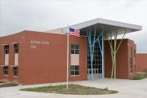
  - Edmunds Elementary Wildcat Newsletter:
  - On the Prowl
October

Smarter…Better…Edmunds Power! |  | Important Dates
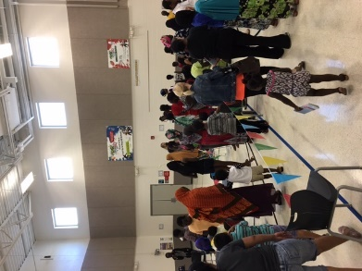
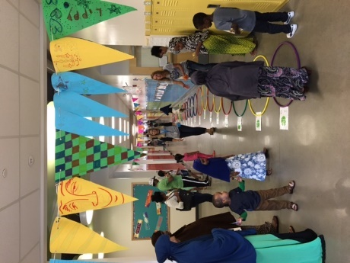
Family Fun Night
Edmunds first Annual Family Fun Night was a great success! The school was decorated with balloons and pennants welcoming students and families for a fun night of games, food and prizes. Every grade level had a station set up for the fun and gave out prizes as students made their way around Edmunds. There was also a Bake Walk, a Game Walk, a Pop Walk and a photo station capturing images of the Strong Man, Strong Woman and friendly Lion. A Taco dinner was also served in the Cafeteria. Fun was the goal for the night and based on the smiles, the night a huge success! Finally, as students walked out after the 90 minute Family Fun, they also received a bag of popcorn. It looks like this special event will be another
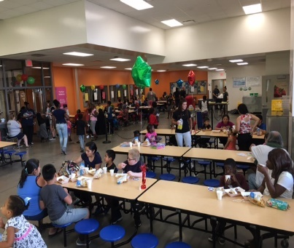
tradition at Edmunds that students and their families will look forward to!
10.4.2017 Early Dismissal 1:40 Parent Teacher Conferences 2-8pm

10.5.2017 Parent Teacher Conferences 4-8pm

10.26.2017
Popcorn Friday $.50

10.27.2017
No School – Professional Development

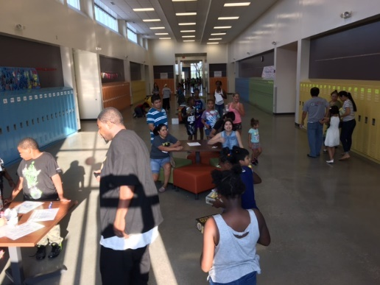

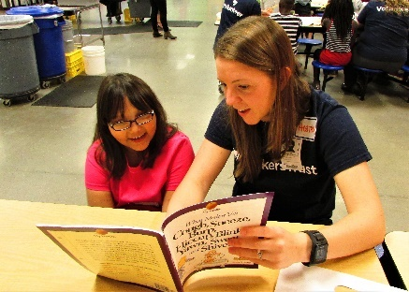
United Way of Central Iowa Day of Caring.
The United Way of Central Iowa teamed up with Edmunds Elementary on September 12th as part of the 2017 United Way Day of Action. For one hour that morning community volunteers worked one-on-one with Edmunds 3rd graders, utilizing a literacy kit based on the book What Makes You Cough, Sneeze, Burp, Hiccup, Blink, Yawn, Sweat, and Shiver? by Jean Stangl. Each kit contained a book and step-by-step instructions for associated activities. The project was designed to reinforce the comprehension strategies learned in the classroom, while exploring common bodily actions. The 3rd Graders has an excellent time with their new United Way friends, as well as a fun time while they learned. Thank you United Way of Central Iowa – the students love their new books!
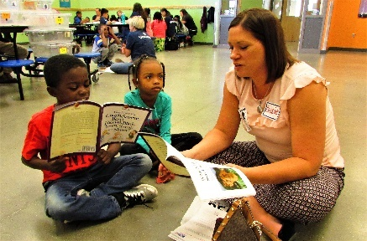

Each month we will feature a new breath or pose for you to try with your child at home. The students can teach you how and when to use these breaths and poses; as they are getting really good at using yoga to help themselves self-regulate and show others respect.
Balloon Breath
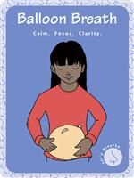
Begin in standing or sitting Mountain with a tall, straight spine. Close your eyes and place your hands gently on your lower belly. Imagine that your belly just turned into a balloon. Slowly inflate the balloon by breathing in through your nose. Feel your belly expand as your balloon fills with air. Slowly deflate your balloon by exhaling the stale balloon air through your nose. Repeat 4-6 times. Notice how you feel. Balloon breathing calms our bodies, while an increased supply of oxygen helps us to think more clearly and feel great.

DMPS Equity & Nondiscrimination Policy

It is the policy of the Des Moines Community School District not to illegally discriminate on the basis of race, color, national origin, sex, disability, religion, creed, age (for employment), marital status (for programs), sexual orientation, gender identity and socioeconomic status (for programs) in its educational programs and its employment practices. There is a grievance procedure for processing complaints of discrimination. If you believe you have (or your child) has been discriminated against or treated unjustly at school, please contact the Equity Coordinator, Isaiah McGee at 2323 Grand Avenue, Des Moines, IA 50312 or 515-242-7662 or isaiah.mcgee@dmschools.org.

Arabic
إسمى مونيكا اكوين، يسعدني أن أرحب بكم في العام الدراسى 2017-2018! أنا المترجم لمدرستى روزفلت وهوفر الثانوية بألإضافة إلى ألمدارس ألإبتدائية و ألمتوسطة ألمجاورة (تتضمن مدرسة أدموندس). واحدة من وظائف عملى هو أن اكون الجسر الذى يربط موظفي المدرسة وأولياء الأمور عن طريق الإعلام والترجمة. أتكلم العربية والدينكا ومن دواعى سرورى أن ألتقي بك قريياً. إذا كان لديك أي أسئلة أو إستفسارات خاصة بألطفل أو المدرسة إتصل بألهاتف 7272-242(515) أو 4646-242(515). ولكم جزيل ألشكر!
Española
Mi nombre es Haruko Nakata y trabajo para las Escuelas Públicas de Des Moines como Coordinadora Familiar Bilingüe, y asisto a las familias de habla hispana en nuestro distrito escolar. Mi horario es de Lunes a Viernes de 8:00 am a 4:00 pm. Mi correo electrónico esHaruko.Nakata@dmschools.org, mi teléfono es 515-242-7883, y tambien puede dejarme correo de voz en español. Por favor no dude en comunicarse conmigo si tiene alguna pregunta o si necesita ayuda para comunicarse con la escuela de su hijo(a).

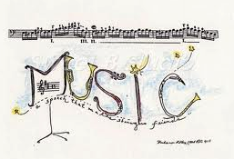
Sing Along with Mrs. Northfield
We have had a great start to the year! Students are settling in and having a lot of fun learning new dances, and singing games! In the month of October students in 4th and 5th grades are learning how to compose their own percussion accompaniments by using body percussion. They have already begun this process in September, by writing out rhythms that match the speech patterns of foods you could find at a market. Second and third graders are reading and discovering the rhythms to some of their favorite music games. Kindergarten and first grade students are practicing how to use their head and chest voice using a variety of rhyming games. These students are also focusing of the difference between high and low sounds, using a variety of movement and singing games.
In the World of Art with Mr. Borzo
We are excited about all the work our young artists are accomplishing in art class this school year. We have many art projects working: 3rd through 5th grade classes have been working on understanding what’s called “negative space” in art work. The students are given a choice of materials to use for this unit, and they are working to see the positive and negative spaces in their piece. Kindergarten and 1st grades are working on shapes and color in October, specific instruction but with open-ended imagination! The 3rd, 4th and 5th grade classes have now all received their personal sketchbooks for use in class, part of many donations we received in the art room this year. The sketchbooks are being used in class, and at the end of the year the students get to take the sketch pads home and show off all their excellent work! Many generous donors contributed personally to Edmunds art or through “donorschoode.org” organization. We thanks them all!
Counselor Corner with Mrs. Moore
I am excited to begin teaching all students The Zones of Regulation this year. The Zones are a way to categorize our feelings/states of alertness so that we can recognize our emotions and choose an appropriate strategy to manage the Zone we are in. There are 4 Zones: Blue Zone = low energy (sad, tired, sick, bored, etc.), Green Zone = calming energy (ready to learn, calm, happy, etc.), Yellow Zone = increased energy (scared, excited, silly, frustrated, etc.), and Red Zone = very heightened alertness (angry, out of control, etc.). All teachers will use the Zones language and you can help increase your child’s emotional vocabulary by using it at home, too! As it is almost the time of year for fall festivities and trick-or-treating, please be sure to review safety tips and ensure your child has adult supervision. We will review at school as well! In addition to classroom counseling lessons, I will meet with some students individually or in small groups. Examples of things I may meet with your student about include: friendship, conflict resolution, social skills, attendance, and school success skills. If you have any questions or concerns, please feel free to call the school or email me at taylor.moore@dmschools.org.
Let the Games Begin in P.E. with Mr. Heard
It’s hard to believe the first month of school is already over! Students have been learning about different ways to move around the gym safely during tag and invasion games. During the month of October, students will be practicing/performing fitness testing. The tests included are the PACER running test, Push-Up test, Curl-Up test, Sit-N-Reach Flexibility test, and the Shoulder Stretch. We will also be measuring their height and weight. These are important to us because we get to measure where they are and how much they grow over the school year. Thank you for investing in your students and their health. Make sure to get outside to play while you still can before the snow hits!

2018-2019 School Year
PATRON NOTIFICATION
Between District Open Enrollment
Iowa Administrative Code 281-17.3(2)
Parents/Guardians considering the use of the open enrollment option to enroll their children in another public school district in the state of Iowa should be aware of the following dates:

DEADLINES:
March 1, 2018 is the last date for regular open enrollment requests for the 2018-2019 school year.

September 1, 2018 is the last date for open enrollment requests for entering kindergarten students and those students falling under the “good cause” definition for the 2018-2019 school year. To insure that the transfer of individual students does not adversely affect the diversity plan of the District, certain limitations to open enrollment have been established. Parents of kindergarten students are therefore encouraged to make application requests prior to March 1, 2018.

APPEALS:
Within 30 days of a denial of an open enrollment request by the DMPS Board of Education, a parent/guardian may file an appeal with the state board of education only if the open enrollment request was based on repeated acts of harassment or a serious health condition of the student that the district cannot adequately address. All other denials must be appealed to the district court in Polk County.

ATHLETIC ELIGIBILITY:
In most cases, a high school student who open enrolls is ineligible for varsity athletic competition during the student’s first 90 consecutive school days of enrollment in the receiving district. Some, but not all, exceptions to this general rule of ineligibility are as follows:
- The sending district does not offer the sport in question.
- The sending district was dissolved and merged with one or more other districts.
- The sending district whole-grade shares with another district for the student’s grade level.

TRANSPORTATION:
Parents/Guardians of students open enrolled from another school district are eligible for transportation assistance if the household income of the parent/guardian is at or below the federal poverty guidelines for household size. The two districts must be contiguous. Assistance may be in the form of actual transportation or in the form of a cash stipend. Information regarding transportation eligibility and a complete copy of the District’s open enrollment policy and procedures may be obtained from the Open Enrollment Office, 2100 Fleur Drive, Des Moines, IA 50321

Año Escolar de 2018-2019
NOTIFICACIÓN DE USUARIOS
Entre la inscripción abierta de distrito
Iowa Código administrativo 281-17.3(2)
Padres/tutores teniendo en cuenta el uso de la opción de inscripción abierta para inscribir a sus hijos en otro distrito de la escuela pública en el estado de Iowa los padres o tutores deben ser conscientes de las siguientes fechas:
PLAZOS:

01 de Marzo de 2018 es el plazo para las solicitudes regulares de inscripción abierta para el año 2018-2019.
01 de Septiembre de 2018 es el plazo para las solicitudes de inscripción abierta para estudiantes de Kinder y los estudiantes pertenecientes a la definición de "buena causa" para el año 2018-2019. Para asegurar que la transferencia de estudiantes individuales no afecta el plan de diversidad del distrito, se han establecido ciertas limitaciones para abrir la inscripción. Los padres de los estudiantes de Kinder por lo tanto animamos a realizar solicitudes de aplicación antes de 01 de Marzo de 2018.

APELACIÓN:
Dentro de 30 días de una denegación de una solicitud de inscripción abierta por la Junta de Educación de DMPS, un padre o tutor puede presentar una apelación ante la Junta de Educación del Estado sólo si la solicitud de inscripción abierta se basaba en repetidos actos de acoso o una condición de salud seria del estudiante que el distrito no puede responder adecuadamente. Todos otros rechazos deben apelarse ante el Tribunal de Distrito en el Condado de Polk
ELEGIBILIDAD ATLÉTICA:

En la mayoría de los casos, un estudiante de secundaria de inscripción abierta es inelegible para competencias atléticas de varsity durante primeros 90 días consecutivos de inscripción del estudiante en el distrito de recepción. Algunos, pero no todos, excepciones a esta regla general de inelegibilidad son los siguientes:
1. El distrito envíado no ofrece el deporte en cuestión.
2. El distrito envíado fue disuelta y se fusionó con uno o más distritos.
3. Las acciones de grado conjunto Distrito envía con otro distrito para el grado del estudiante.
TRANSPORTE:

Los padres/tutores de estudiantes abiertos de otro distrito escolar son elegibles para asistencia de transporte si el ingreso de los padres/tutores es igual o por debajo de las pautas federales de pobreza para el tamaño de la familia. Los dos distritos deben ser contiguos. Asistencia puede ser en la forma de transporte real o en forma de un estipendio de efectivo. Puede obtenerse información sobre la elegibilidad de transporte y una copia completa de inscripción abierta política del distrito y los procedimientos de la oficina de inscripción abierta, 2100 Fleur Dr., Des Moines, IA 50321

