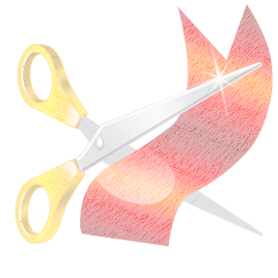



**Please join the Edmunds Staff in a ribbon cutting ceremony to open the new Edmunds building!**

**After the ribbon cutting ceremony we will hold an open house for parents and students. You will tour the new building and meet new staff!**

**You may bring school supplies to drop off in the classroom.**

**\*\*Treats and books for families who complete the open house scavenger hunt!\*\***

**Please join the Edmunds Staff in a ribbon cutting ceremony to open the new Edmunds building!**

**After the ribbon cutting ceremony we will hold an open house for parents and students. You will tour the new building and meet new staff!**

**You may bring school supplies to drop off in the classroom.**

**\*\*Treats and books for families who complete the open house scavenger hunt!\*\***

**Time:**

**Ribbon Cutting: 5:00**

**Open House:**

**5:30-7:00 pm**

**Who:**

**Edmunds**

**Families**

**Where:**

**The New Edmunds Building**

**Date:**

**Monday August 12th**

**950 15th Street,**

**Des Moines, Ia**

**50314**

**Edmunds Elementary**

Ribbon Cutting Ceremony &

Open House

Invites you to join us for our